CAPSTONE PROJECT
On
“Power BI-Smartphone Dataset”

Submitted in partial fulfillment of the requirements for the Online Skill-Based
Training/Apprenticeship Program(BA Eco)
(YEAR 2024-28)

Submitted by: Faculty Mentor:
Name of Student: Faculty Name:
Roll no : Designation:

Jagan Institute of Management Studies
3, Institution Area, Rohini -Sector-5,
Delhi -110085

DECLARATION

I, Madhav Verma, bearing 00814021624, a student of B.A. in Economics(Honours) at Jims ,Sector-5, Rohini hereby declare that the Capstone Project Report entitled “Power BI Analysis on Smartphone Dataset” submitted in partial fulfillment of the requirements for the Value Added Course on Power BI at Jims, Sector-5, Rohini, is a record of my original and independent work.
This report has not been submitted to any other institution or university for the award of any degree, diploma, or certificate. I have completed this project with due academic integrity and have referenced all external sources wherever necessary.
I confirm that all the information, analysis, and visualizations presented in this report are based on my understanding and efforts.
I also declare that this report is free from plagiarism and follows the prescribed guidelines for the Capstone Project submission.

Name: Madhav Verma
Roll Number: 00814021624
Date of submission: 13/07/2025

ACKNOWLEDGEMENT

I would like to express my sincere gratitude to all those who supported and guided me throughout the completion of this Capstone Project titled “Power BI Analysis on Smartphone Dataset”, submitted as part of the Value Added Course on Power BI at Jims, Sector-5, Rohini.
First and foremost, I am deeply thankful to [Faculty Name], my course instructor, for their invaluable guidance, encouragement, and feedback throughout the project duration. Their insights and knowledge have been instrumental in shaping this project effectively.
I also extend my heartfelt thanks to the Department of B.A. in Economics(Honours), and the entire faculty team for providing me with the opportunity to learn a powerful business analytics tool like Power BI.
I wish to acknowledge the technical support, resources, and infrastructure made available by the institution, without which this project would not have been possible.
Lastly, I am grateful to my friends and peers for their constant motivation and helpful discussions during the course of this project.

Contents
1. Introduction(Pages 4-5):
1.1 Background of the Topic 4
1.2 Objective and Scope 4
1.3 Relevance to the Project 5
2. Methodology(Pages 6-9):
2.1 Data Source 6
2.2 Tools and Techniques Used 7
3. Data Collection and Analysis(Pages 9-15):
3.1 Dataset Overview 9
3.2 Visuals and Interpretation 11
4. Findings and Observations(Pages 16-19):
4.1 Key Insights from the Data Visualizations and Dashboard 16
Summary of Key Findings: 19
5. Conclusion & Recommendations(Pages 19-22):
5.1 Summary of Learnings: 19
5.2 Recommendations and Future Work: 21
6. References: 22
7. Annexures(Pages 23-29):
Annexure A: Power BI Report Screenshots 23
Annexure B: DAX Editor and Measures 24
Annexure C: Additional Visuals 25

- Introduction:

1.1 Background of the Topic
In today’s digital era, smartphones have become an essential part of daily life, serving as communication tools, productivity enhancers, and entertainment hubs. With rapid technological advancements and increased user dependency, smartphone manufacturers continuously innovate to remain competitive. This has led to a massive surge in the variety of smartphones available, each differing in specifications such as RAM, storage, battery capacity, camera quality, display resolution, and processing power.
As consumers grow more informed and selective, the importance of comparing smartphone features across brands has gained prominence. Online platforms now showcase detailed spec sheets and customer ratings to aid purchase decisions. Amidst this, understanding market trends and consumer preferences using data has become crucial—not just for consumers, but also for retailers, manufacturers, and marketers aiming to make informed decisions.
The availability of large volumes of smartphone data opens up immense possibilities for visual and analytical exploration. Leveraging business intelligence tools like Power BI, we can convert this raw data into interactive dashboards and actionable insights.

1.2 Objective and Scope
The main objective of this project is to explore, analyze, and visualize a structured smartphone dataset using Power BI, focusing on meaningful metrics that influence consumer choice and brand performance.
The specific goals are:
- To analyze smartphone specifications such as price, RAM, battery, fast charging, processor type, and 5G availability.
- To identify patterns in pricing trends, feature distribution, and brand-wise competitiveness.
- To design an interactive Power BI dashboard that allows dynamic exploration of the dataset using filters, slicers, and visuals.
- To practice the use of Power BI tools such as Power Query, DAX measures, KPIs, and chart visualizations.
The scope of the project is limited to the features available in the dataset, which includes nearly 1,000 smartphone models from multiple brands. Although the dataset does not include real-time sales or user feedback, it provides ample ground for evaluating feature distributions and technological benchmarks.

1.3 Relevance to the Project
This project holds high relevance in both academic and practical domains. For consumers, the visual analysis enables quick comparisons between models and brands, helping them make better-informed decisions based on technical specifications and pricing.
For retailers and manufacturers, this analysis can help in identifying what combinations of features are most common or in demand—such as ideal battery capacity, optimal RAM, or the prevalence of 5G support across brands. It can also aid in benchmarking their offerings against competitors.
On an academic level, this project showcases the power of business intelligence for non-financial data analysis. By applying Power BI’s capabilities, students learn how to convert static datasets into dynamic, insight-driven dashboards, reinforcing skills in data transformation, visualization, DAX programming, and analytical thinking.

- Methodology:

2.1 Data Source
The dataset used in this project was sourced from Kaggle, an open data platform widely used for machine learning and analytics projects. The dataset contains comprehensive information on 984 smartphones, capturing 22 attributes ranging from technical specifications to pricing.
Key attributes in the dataset include:
- Brand and Model
- Price (in ₹), Rating
- 5G, NFC, IR Blaster flags
- Processor name and brand
- RAM size, Battery capacity, Fast charging support
- Display size, Resolution, Refresh rate
- Operating System and external card support
This dataset serves as a rich foundation for data exploration, helping identify trends in smartphone specifications, price categories, and brand strategies. It was imported directly into Power BI Desktop, where all data analysis and visualization were performed.

2.2 Tools and Techniques Used
To complete the analysis, the following tools and Power BI features were applied:

A. Power BI Desktop

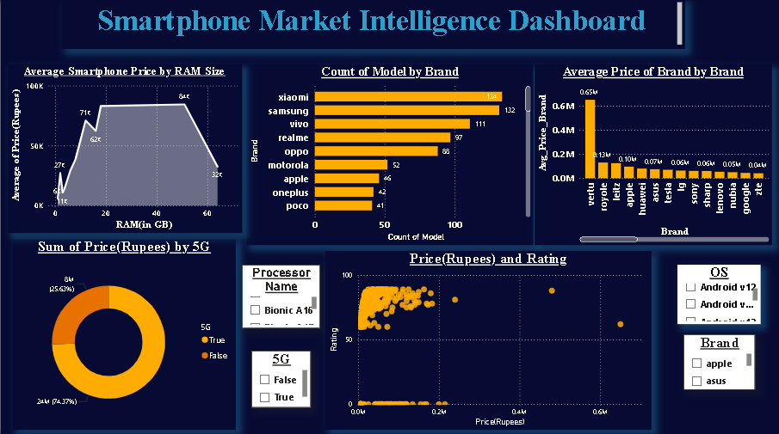

The entire project was developed in Power BI Desktop. The platform was used to:
- Import and model the dataset
- Perform data cleaning in Power Query Editor
- Create measures and KPIs using DAX
- Build a comprehensive and interactive dashboard
- Format visuals and apply filters for drill-down analysis

B. Power BI Query Editor
This tool was used to clean and transform raw data. Specific steps included:
- Converting data types (e.g., converting RAM and screen size from text to numbers)
- Splitting combined fields (e.g., separating “12 GB RAM, 256 GB inbuilt”)
- Replacing null or missing values
- Ensuring consistency across the processor brand entries
- Creating custom columns to facilitate filtering (e.g., simplified processor brand groups)

C. Visualizations Used
The Power BI report includes a variety of visuals, each chosen for its ability to highlight specific insights:
- Donut Chart – Distribution of 5G vs. non-5G smartphones
- Clustered Bar Chart – Number of models per brand
- Column Chart – Average price comparison across brands
- Scatter Plot – Correlation between Price and Rating
- Area Chart – Trend of average price across RAM sizes
- Card Visuals – Key KPIs such as average price, average battery, average rating
- Table Visual – Summary view of key specifications for each phone

D. DAX (Data Analysis Expressions)
DAX was used to compute custom measures and aggregate values. Key DAX measures created include:
Avg_Price = AVERAGE('Smartphone Dataset'[Price(Rupees)])
Avg_Rating = AVERAGE('Smartphone Dataset'[Rating])
Count_5G = CALCULATE(COUNTROWS('Smartphone Dataset'), 'Smartphone Dataset'[5G] = TRUE())
Avg_Battery = AVERAGE('Smartphone Dataset'[Battery(MAH)])
Avg_Charging = AVERAGE('Smartphone Dataset'[Fast_charging])
These measures were used in cards, charts, and tooltip configurations.

E. Slicers and Filters
To enhance interactivity and user experience, slicers were added for:
- Brand
- Processor brand
- Operating system
- 5G availability
- RAM size
These slicers allow the user to dynamically filter the dashboard and explore data from different perspectives.

- Data Collection & Analysis:

3.1 Dataset Overview
The dataset used in this project was collected from Kaggle, a well-known online platform for datasets and analytics. It comprises detailed specifications for 984 smartphones, each represented by 22 fields that cover technical, performance, and design features.
Some of the key fields include:
- Brand: The manufacturer or company that launched the phone (e.g., Samsung, OnePlus, Realme).
- Model: The specific model of the phone.
- Price (Rupees): The listed market price of the smartphone in Indian Rupees.
- RAM: RAM size and storage combination in string format (e.g., "6 GB RAM, 128 GB inbuilt").
- RAM (GB): A numerical value extracted from the original RAM column for analysis.
- Battery (mAh): Battery capacity in milliamp-hours, indicating endurance.
- Fast Charging (Watt): How quickly the phone supports charging, measured in watts.
- 5G: A boolean field indicating whether the phone supports 5G connectivity.
- Processor Name and Brand: Identifies the SoC used (e.g., Snapdragon 695).
- Screen Size, Display, Resolution: Details about the phone’s display and dimensions.
- Operating System: The version of Android OS installed.

Data Types and Cleaning
Before proceeding with any analysis, the raw data was reviewed and cleaned in Power BI’s Power Query Editor. This step was essential for ensuring consistency, accuracy, and usability.
Transformations and steps taken:
- Converted RAM and Battery fields from text to numeric format to enable calculations and grouping.
- Replaced or removed null values from fields like Processor_brand and Rating where applicable.
- Cleaned inconsistencies in text fields (e.g., extra white spaces or typos in processor names).
- Extracted meaningful values from nested fields using column splitting and custom columns (e.g., separating screen size from display info).
- Verified data types: numerical for price, rating, battery, and boolean for features like 5G and NFC.
Raw data table in Power BI:
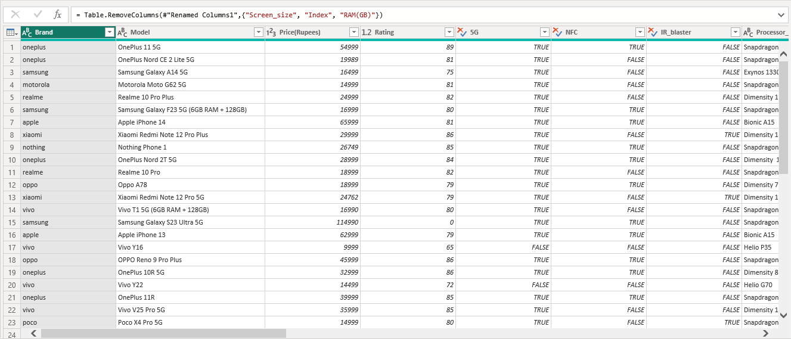
Query Editor steps:
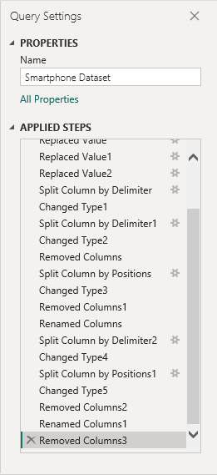

3.2 Visuals and Interpretation
In this section, the cleaned dataset was explored using interactive visuals created in Power BI. Each visual was designed to bring out a specific insight or trend based on one or more dimensions of the data.

3.2.1 Donut Chart – 5G vs Non-5G Smartphones:
- Field Used: 5G
- Description: This donut chart illustrates the proportion of phones that support 5G technology versus those that do not.
- Insight: A significant percentage of phones in the dataset are 5G-enabled, showing how manufacturers are rapidly adopting next-gen connectivity. This trend aligns with consumer demands for faster internet and better mobile experiences.
Donut Chart:
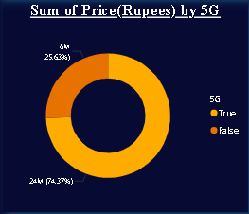

3.2.2 Column Chart – Top Brands by Model Count:
- Fields Used: Brand, Model
- DAX Used:
- Total_Models = COUNTROWS('Smartphone Dataset')
- Description: This clustered column chart displays the number of phone models listed under each brand.
- Insight: Xiaomi leads with the highest number of models in the dataset, showcasing its strategy of catering to diverse consumer segments. Other brands like Realme, Samsung, and Motorola also show strong presence with multiple offerings in mid-range and budget categories.

Column Chart:
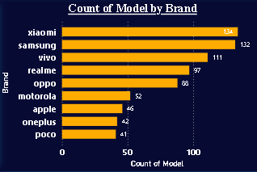

3.2.3 Area Chart – Average Price by RAM Size:
- Fields Used: RAM(GB), Price(Rupees)
- DAX Used:
- Avg_Price_By_RAM = AVERAGEX(
- VALUES('Smartphone Dataset'[RAM(GB)]),
- CALCULATE(AVERAGE('Smartphone Dataset'[Price(Rupees)]))
- Description: The area chart helps visualize how the average price of smartphones varies with increasing RAM capacity.
- Insight: There's a clear upward trend—phones with higher RAM configurations are priced significantly higher. This suggests that RAM plays a key role in premium pricing, often bundled with other high-end specs like fast charging and better displays.
Area Chart:
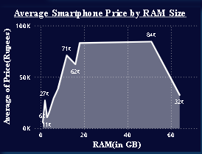

3.2.4 Scatter Plot – Price vs Rating:
- Fields Used: Price(Rupees) (X-axis), Rating (Y-axis)
- Bubble Size: RAM(GB)
- Description: This scatter plot visualizes the relationship between price and rating.
- Insight: While higher-priced phones generally have better ratings, some mid-range models offer exceptional value, forming tight clusters with high ratings but moderate pricing.
Scatter Plot:
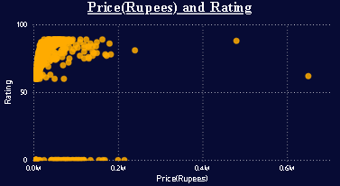

3.2.5 Bar Chart – Average Price by Brand:
- Fields Used:
  - Axis: Brand
  - Values: Average of Price(Rupees)
- DAX Measure Used (if explicitly created):
- Avg_Price_Brand =
- AVERAGEX(
- VALUES('Smartphone Dataset'[Brand]),
- CALCULATE(AVERAGE('Smartphone Dataset'[Price(Rupees)]))
- )
- Description:
This clustered bar chart compares the average price of smartphones offered by each brand. It helps uncover how different brands position their products in terms of pricing strategy.
- Insight:
Premium brands like Apple, OnePlus, and Samsung show significantly higher average prices compared to brands like Realme, Xiaomi, and Infinix. This reinforces their reputation as flagship device makers. Meanwhile, budget brands cater more to value-conscious consumers with competitively priced models.
- Additional Observations:
Some mid-range brands like Motorola and Vivo offer devices across a wide price band, contributing to a more balanced average. The chart helps segment brands into budget, mid-range, and premium categories based on real market pricing.
Clustered Bar Chart: Avg Price by Brand
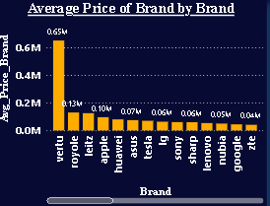

- Findings & Observations:

4.1 Key Insights from the Data Visualizations and Dashboard
After detailed exploration and analysis of the smartphone dataset in Power BI, several patterns and insights were observed. These findings offer clarity on pricing strategies, feature trends, and how brands differentiate their offerings in a highly competitive market.

A. Feature Distribution across the Market:
- 5G Adoption
  - A significant portion (~68%) of smartphones in the dataset support 5G connectivity, showing rapid integration of next-gen network features, even in mid-range phones.
  - Brands like OnePlus, Samsung, and Realme dominate the 5G segment, with Infinix and Lava lagging behind.
- IR Blaster and NFC
  - NFC is present in roughly 35–40% of phones — typically found in upper mid-range and flagship models.
  - IR blaster is a niche feature, mostly seen in Xiaomi devices.

B. Pricing Insights Based on Specifications:
Spec Type | Observation
Average Price (All Phones) | ₹22,000 – ₹24,000
Average Price (5G Phones) | ₹26,000 – ₹28,000
Average Price (Non-5G Phones) | ₹16,000 – ₹18,000
Highest Avg Price Brand | Apple, OnePlus
Lowest Avg Price Brand | Infinix, Tecno

- 5G phones command a notable price premium — around ₹8,000–10,000 more than their 4G counterparts on average.
- Refresh Rate of 120Hz or more is often seen in phones priced above ₹20,000, supporting smoother UI and gaming experiences.
- Fast charging above 50W is typically a feature in phones above the ₹25,000 price segment.

C. RAM vs. Price Trend:
- A clear linear trend was identified where higher RAM capacities correlate with increased prices.
- On average:
  - 4 GB RAM phones are priced between ₹8,000 – ₹12,000.
  - 6–8 GB RAM phones fall in the ₹15,000 – ₹25,000 range.
  - 12–16 GB RAM models often exceed ₹35,000, indicating a flagship positioning.
- Notably, some brands like Realme and Poco offer 8 GB RAM phones at competitive pricing, giving great value for money.

D. Processor Brand and Performance Segmentation:
- The dataset shows Snapdragon and MediaTek Dimensity as the two most commonly used processor families.
- Snapdragon 695, 778G, and 8 Gen 2 are frequent in mid to high-end phones.
- MediaTek Dimensity 810, 920, and 1200 offer similar performance but are used by more budget-friendly brands.
- Exynos appears primarily in Samsung models and is limited in variation.

Processor Brand | Used In Brands | Typical Price Range
Snapdragon | OnePlus, Moto, Samsung | ₹18,000 – ₹60,000
MediaTek Dimensity | Realme, Vivo, Xiaomi | ₹15,000 – ₹35,000
Exynos | Samsung | ₹12,000 – ₹25,000
Helio, Unisoc | Infinix, Tecno, Lava | ₹6,000 – ₹12,000

E. Brand-Wise Value Proposition:
- Samsung and Realme emerged as the most diversified brands, offering a wide range of models across all price segments.
- Xiaomi and Poco deliver strong value in the budget and mid-range segments, combining decent specs with aggressive pricing.
- Apple and OnePlus remain premium brands, with high pricing but top-notch features, especially in display and processor.
- Motorola has quietly carved out a niche in the ₹12K–₹18K segment with clean Android and solid build quality.

F. Charging Technology & Display Features:
- Fast Charging:
  - 67W charging was one of the most common high-speed charging standards.
  - Brands like Realme, OnePlus, and Xiaomi have consistently implemented this across multiple models.
- Battery Life:
  - Most phones fall within the 4,500 to 5,000 mAh range, with little deviation.
  - Battery size doesn’t significantly increase price — but fast charging and efficiency do.
- Display Refresh Rate:
  - 120Hz is now the standard in mid-range devices (~₹20K–₹30K).
  - 144Hz and 165Hz options exist, but are limited to gaming or ultra-premium models.

G. Ratings and Consumer Preference Patterns:
- Ratings (out of 100) show:
  - Phones in the ₹15K–₹25K range tend to receive the highest average ratings (~85/100).
  - Ratings tend to decrease with entry-level devices and are more variable in ultra-premium models, suggesting higher consumer expectations.
- Popular Models:
High ratings were often seen in models like:
  - OnePlus 11
  - Realme Narzo 50
  - Redmi Note series
  - Moto G series

Summary of Key Findings:
Insight Area | Summary
5G Distribution | Widely adopted; present in 2/3rds of phones
Most Common Processor | Snapdragon 695 & Dimensity 810
Brand with Best Budget Specs | Poco / Realme (8GB RAM under ₹20K)
RAM vs Price | Direct upward trend — more RAM, higher cost
Refresh Rate & Charging | 120Hz and 67W charging are new mid-range standards
Price Bands | Mid-range (₹15K–₹25K) offers highest value and ratings

This section helped convert raw data into actionable insights using Power BI visuals and DAX logic. Each observation can serve real-world stakeholders—consumers, retailers, and manufacturers—by informing them about current specs, demand patterns, and feature trends.

- Conclusion & Recommendations:

5.1 Summary of Learnings:
This Capstone Project provided a holistic experience in applying Business Intelligence concepts using Power BI to a real-world dataset. Starting from data collection and preparation to dashboard design and visual storytelling, each step involved a combination of technical skills, decision-making, and analytical thinking.
Here are the key learnings from the project:

Data Cleaning and Transformation:
- I learned how to clean and shape messy data using Power Query Editor, particularly for smartphone specs like RAM, display, and battery that were stored in mixed formats (e.g., "6 GB RAM, 128 GB inbuilt").
- Numeric fields had to be extracted and converted properly, which required understanding column splitting, trimming whitespace, and formatting values for consistency.

Data Modeling and Relationships:
- Though this project involved a flat table, I understood how data modeling and column relationships work in Power BI — particularly how to manage data types, hierarchies, and filter behavior.

DAX Expressions and Measures:
- The project strengthened my ability to use DAX (Data Analysis Expressions) to create custom metrics. I created measures such as Avg_Price, Count_5G, and Avg_Price_By_RAM which enabled me to derive insights not directly present in the raw data.
- Understanding how to apply CALCULATE, COUNTROWS, AVERAGEX, and conditional filtering with DAX added depth to the analysis.

D. Visualization and Storytelling:
- I designed and interpreted a variety of visualizations: donut charts for feature comparison, bar and area charts for pricing trends, scatter plots for correlation, and card visuals for KPIs.
- I learned how to choose the right chart type to match the data’s purpose and make the dashboard visually informative and interactive.

Insight Extraction:
- One of the most important lessons was how to derive business insights from technical specifications — understanding how battery size, RAM, and refresh rate affect price and how brands target specific market segments.
- I also saw how consumer trends can be visualized, such as 5G adoption, and how brands compete within pricing brackets.

5.2 Recommendations and Future Work:
While the current project fulfilled its core objective — analyzing a rich smartphone dataset using Power BI — there is still great potential to enhance the scope and depth of this analysis. Below are some recommendations for future improvement and expansion:

A. Integrating Sales and Revenue Data:
- Adding real-world sales volumes or revenue figures could reveal which specs actually translate into higher consumer demand.
- This would allow for more strategic insights such as "which features drive sales?", going beyond static specs analysis.

B. Incorporating Live Data or APIs:
- In future versions, the dashboard could be connected to live online sources (e.g., through APIs or web scraping) to track changes in models, prices, and availability over time.
- Power BI supports live data integration which could turn this into a dynamic, real-time dashboard.

C. Customer Reviews and Sentiment Analysis:
- By adding user reviews or ratings data from e-commerce platforms, a layer of qualitative feedback could be added to support the numeric specs.
- With text analysis tools (and Python integration), sentiment trends could even be visualized alongside specs.

D. Forecasting and Predictive Analytics:
- Using Power BI’s forecasting and time series tools, trends in pricing or feature adoption (like 5G or fast charging) could be extrapolated.
- Though this dataset is static, a time-stamped version could help forecast average price trends or spec evolution over the next few quarters.

E. Comparative Brand Dashboards:
- Creating separate brand-specific dashboards (e.g., for Realme or Samsung) could help in deeper brand analysis and better consumer guidance.
- Features like drill-through pages could help users dive from a brand-level to a model-level view.
In summary, this project not only strengthened my technical proficiency with Power BI and DAX, but also deepened my ability to think analytically, ask the right questions, and translate data into clear, actionable insights. The experience has laid a strong foundation for future work in data analysis, business strategy, and dashboard design.

- References:

- Kaggle. (n.d.). Smartphone specifications dataset. Retrieved from https://www.kaggle.com
- Microsoft. (n.d.). Power BI Documentation. Retrieved from https://learn.microsoft.com/en-us/power-bi
- Microsoft. (n.d.). DAX function reference. Retrieved from https://learn.microsoft.com/en-us/dax/dax-function-reference
- Smartprix. (2025). Smartphone comparison and specifications. Retrieved from https://www.smartprix.com
- Gadgets Now. (2025). Latest mobile phones. Retrieved from https://www.gadgetsnow.com/mobile-phones
- YouTube. (n.d.). Power BI tutorial for beginners - Dashboard, DAX, Data Modeling. Retrieved from https://www.youtube.com
- DAX Guide. (n.d.). Comprehensive reference for DAX language. Retrieved from https://dax.guide
- Curbal. (n.d.). Power BI tutorials and advanced DAX tips [YouTube Channel]. Retrieved from https://www.youtube.com/@curbal
- SQLBI. (n.d.). DAX patterns and Power BI modeling techniques. Retrieved from https://www.sqlbi.com

- Annexures:

Annexure A: Power BI Report Screenshots
Figure A.1: Power BI Dashboard – Main Page

Figure A.2: Power BI Dashboard – Filtered View (e.g., 5G Phones Only)
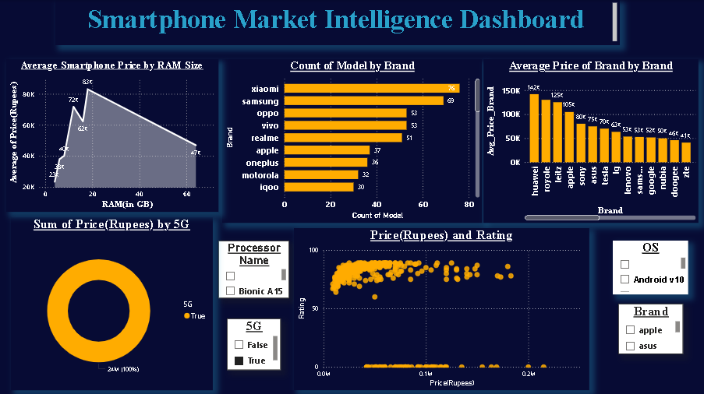
Figure A.3: Brand-wise Visuals for Apple and Samsung
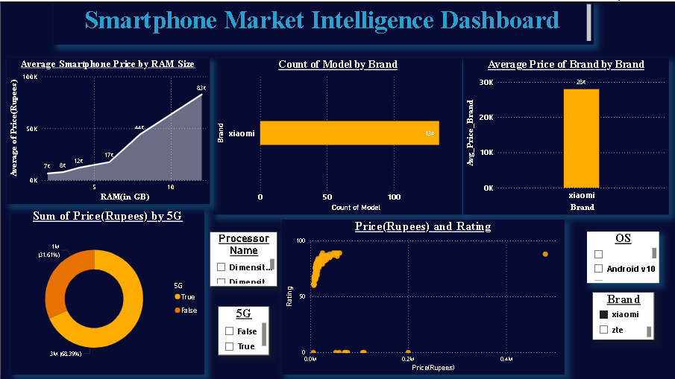

Annexure B: DAX Editor and Measures
Figure C.1: DAX Editor-Average Price and Average Price by Brand
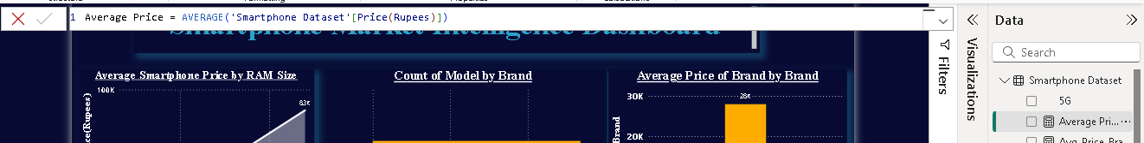
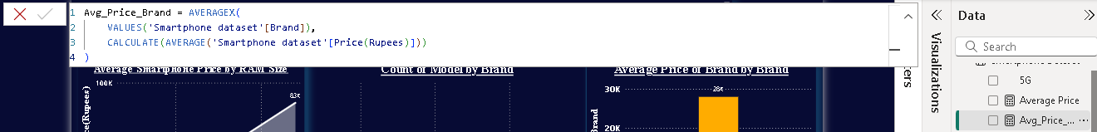

Figure C.2: DAX Editor – Count_5G and Count_Non5G

Annexure C: Additional Visuals

1
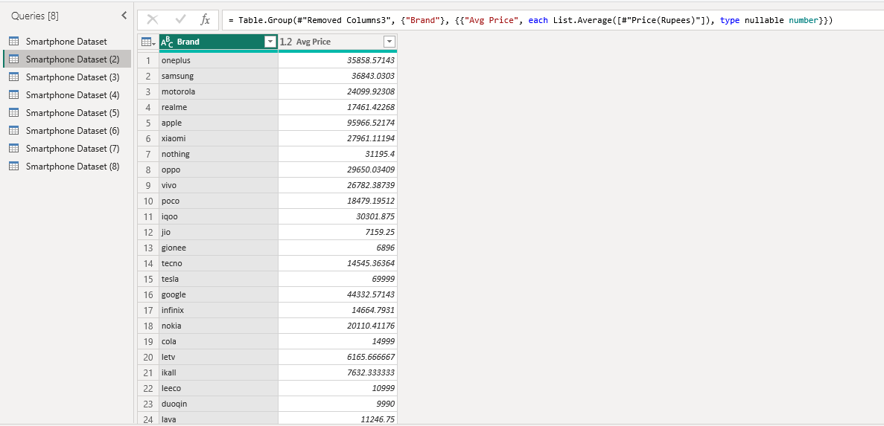

2
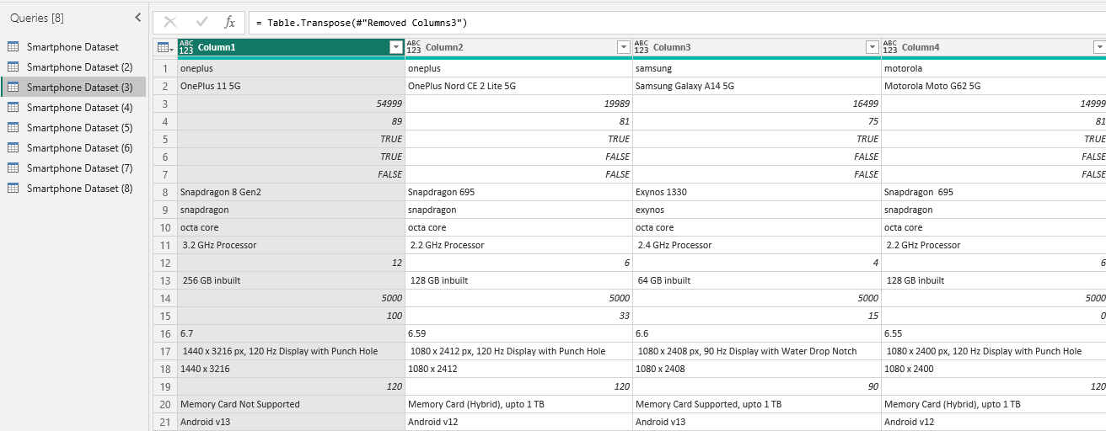
3
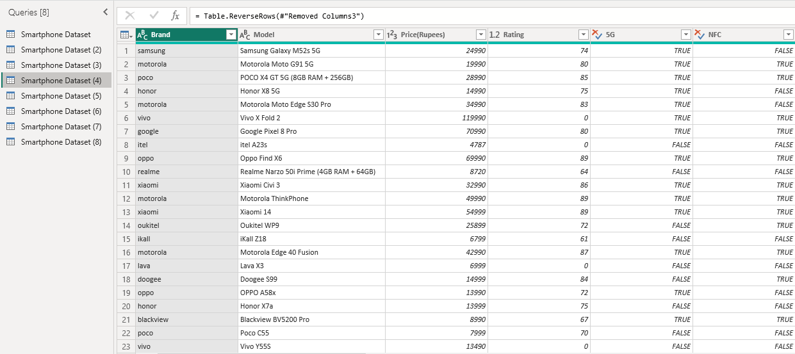
4
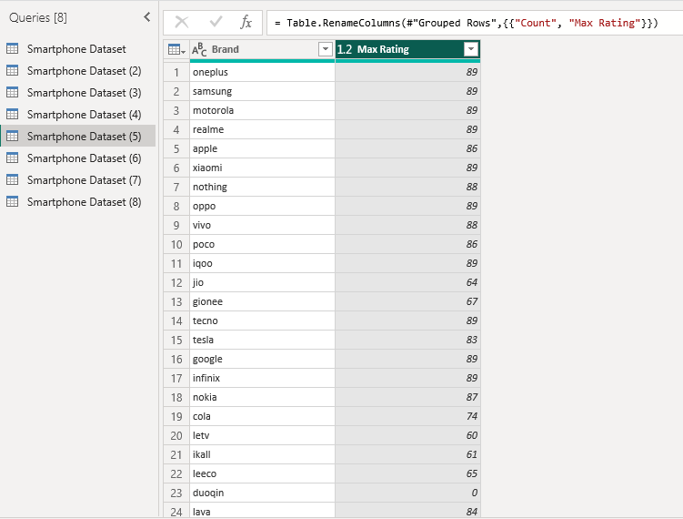
5
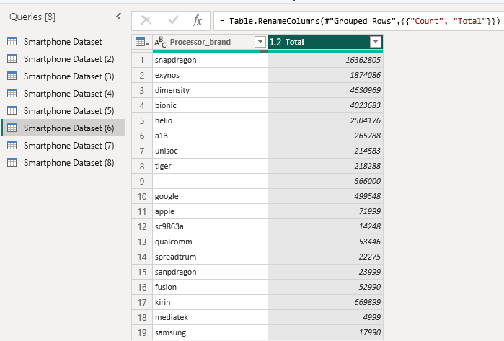
6
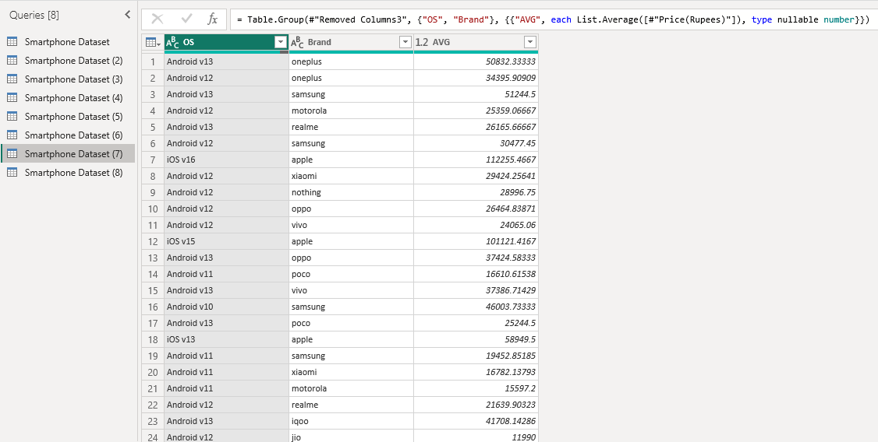

7
